TASK 1:- Digital Literacy Awareness Infographic

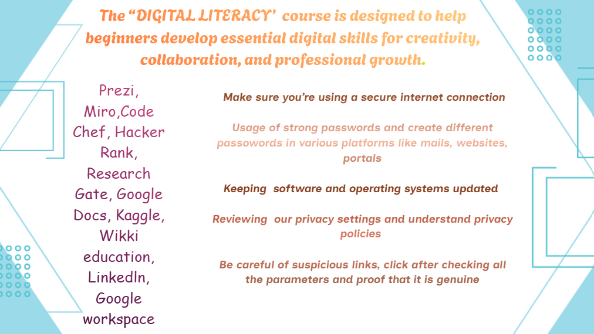
I used Canva presentation tool which is very efficient in making presentations ,videos using ready-made template. It includes gradient colors, contains element section that includes 3-D , shapes, graphics, photos, forms, sheets ,animations ,frames, charts, grids, mockups. We can use variety of fonts and combinations to upgrade our written text and style that attracts the readers.

Many of these are premium text fonts that you need to buy to make use of them. It too has a magic write option in which we can type and it generates
the answer or information which we can directly use in our presentations. We can upload photos of any field like education, business, finance, start up, technology, history and make videos and small ppt’s to showcase knowledge.

Tools help us to beautify presentations by drawing with draw tool, making lines, shapes , and I find sticky notes tool to be the best part of canva as it helps to make short and to the point notes which is pasted in our ppt or reference of a topic. Table tool organize the data.

Projects section collects all your previous and current projects which can be used as per need Magic media generates AI images, videos, graphics, 3-D of what we give description to it.

In the above slide , I have written the definition of digital literacy, furthermore listing out various student digital tools along with internet safety measures to take, as it is necessity to be highly attentive while working on internet.

I found colour platte very interesting as it includes various colours not only solid but also gradient which beautifies the content and seeks attention of the reader.

